### **Multi-Branch Project**

#### **Project Overview**

* Create a simple Java project.
* Version-control the project using Git with multiple branches.
* Set up Jenkins multi-branch pipeline for automated build and deployment.
* Utilize Jenkins environment variables in the Jenkinsfile.

#### **Project Objectives**

* Version-control using Git.
* Jenkins multi-branch pipeline setup.
* Environment variable management using Jenkinsfile.

**Project Deliverables**

**Git Repository:**

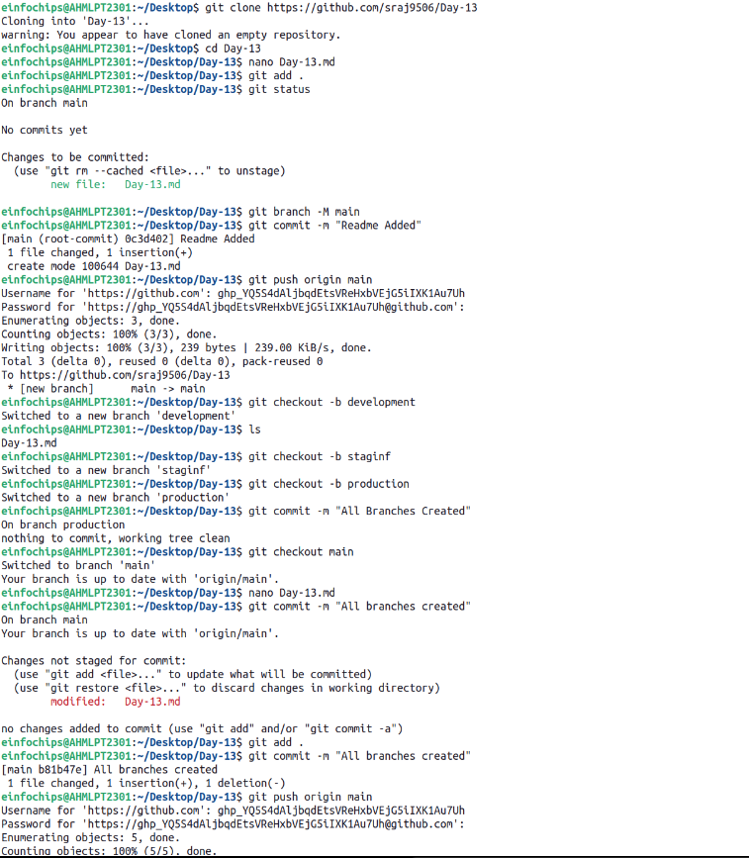

**Java Project:**

We created simple java application in main branch and also on another three branch.

Development :

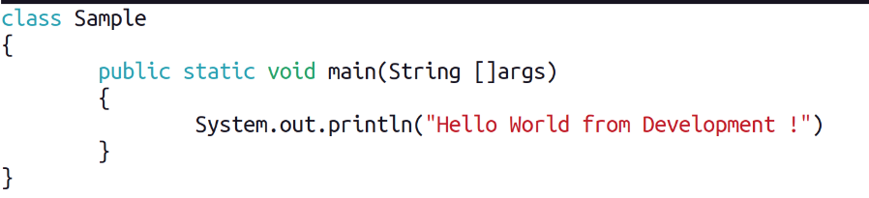

Staging:

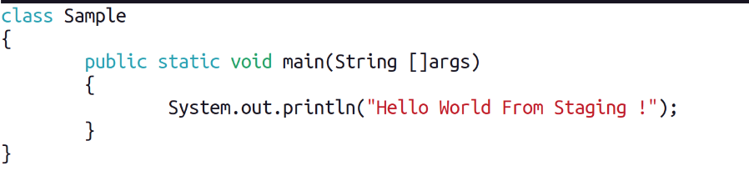

Production:

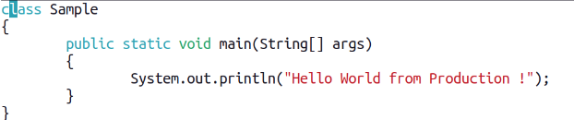

**Jenkins Setup:**

Multi-branch pipeline job configured in Jenkins :

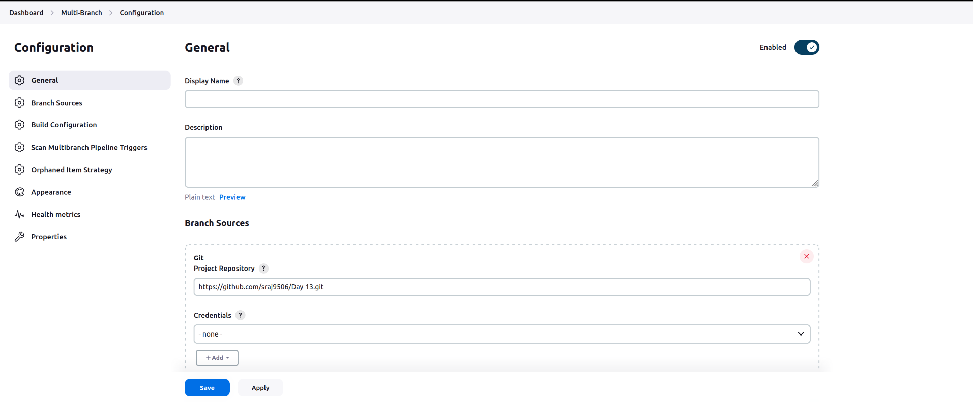

Jenkinsfile defining build and deployment steps.

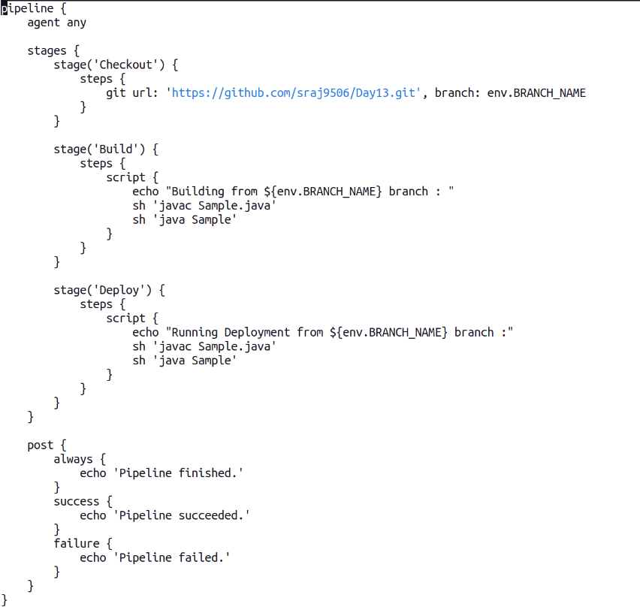

Environment variables managed using Jenkins environment variable settings.

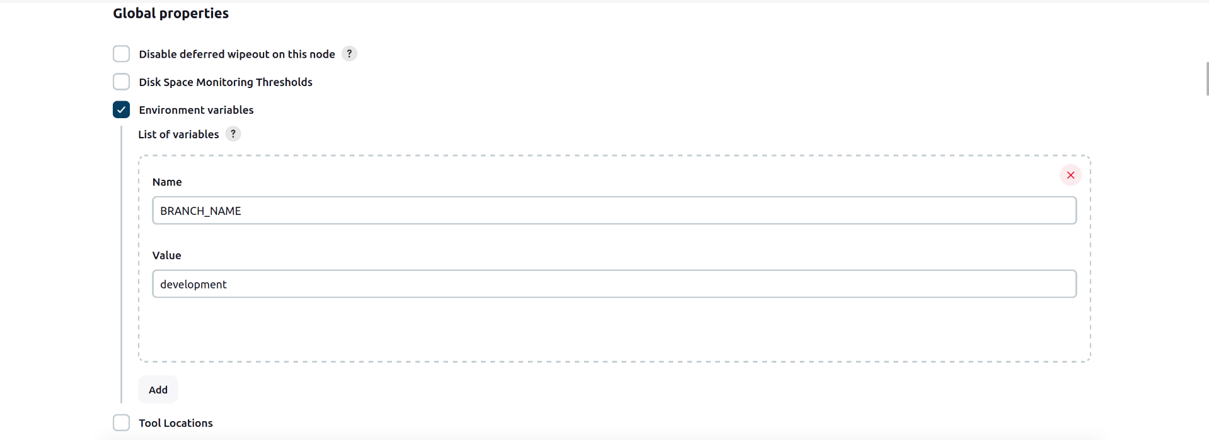**Output**

development branch:

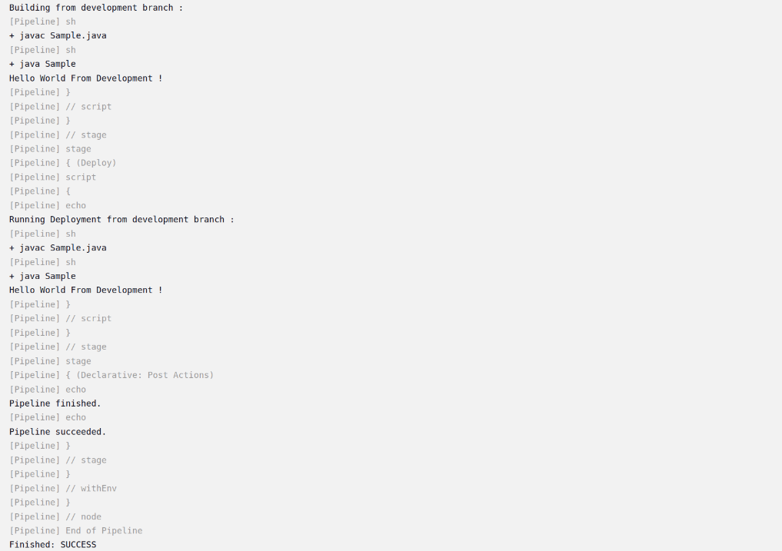

staging branch :

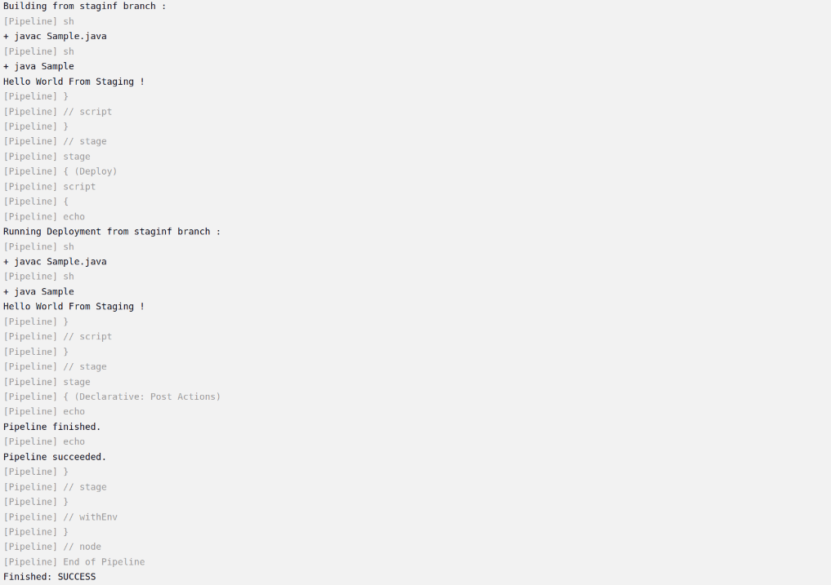

production branch :

